MegaStorm Games

Ross McDade & Alasdair Hendry

Micro Mayhem

Appendix Document

Table of Contents

Design 1

Artwork 1

Sketches 1

# Design

## Artwork

### Sketches

Here, the designs for the characters, weapons and level design that were all explained in the GDD can be found.

#### Characters

Multiple sketches have been created for the different designs for each of the in-game characters. The first of which is the main protagonist, and the playable character, Robopill.

##### Robopill

Here, it can be seen that originally the character was going to run around. However, due to the team members wanting to create a more futuristic/cutting edge of technology look to the character.  
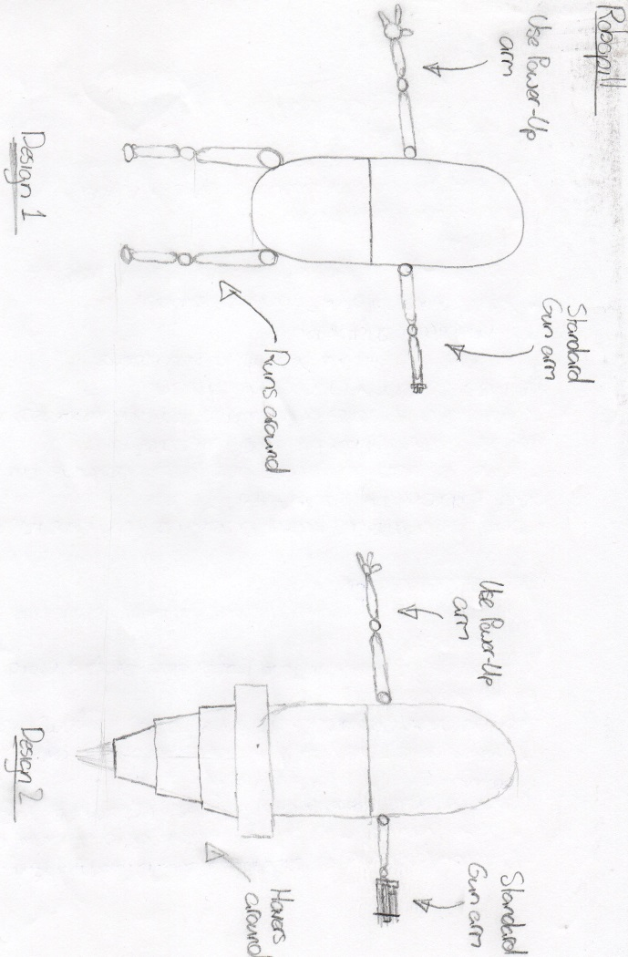

##### Enemy Character Designs

###### Bacteria Reference Images

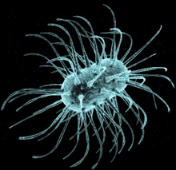[1]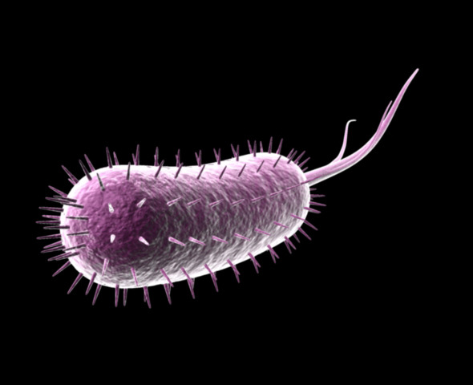[2]

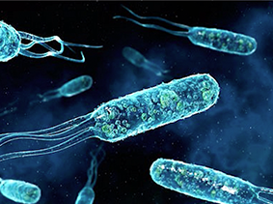[3]

###### Stylised Enemy Designs

As mentioned in the GDD, the enemy designs had originally been discussed and agreed on resembling actual forms of harmful bacteria, as can be seen above. However, it was later decided that for the benefit of the game the enemies should be more stylised and some of them should be more humanoid characters.  
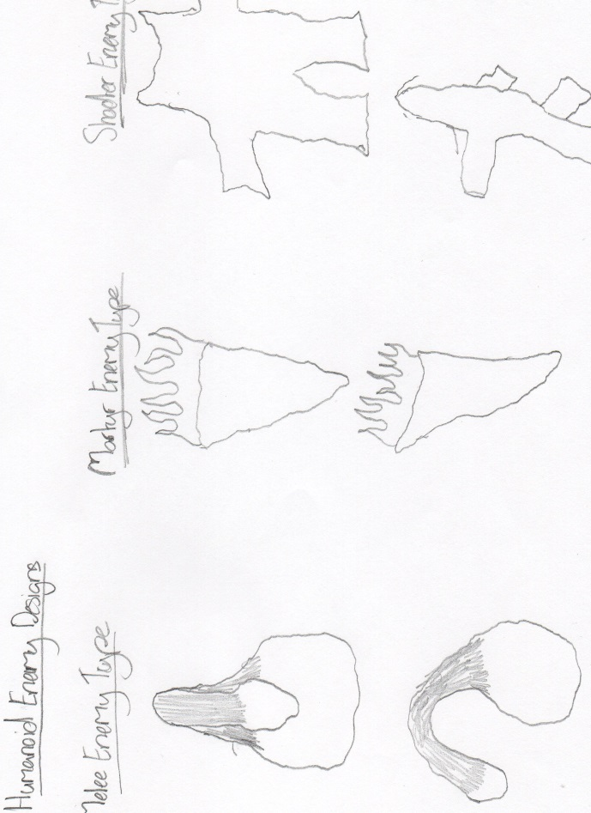

#### UI Design

Something that was very important when creating the UI design was keeping it simple and as minimalistic as possible. These are the sketches and early version of the UI design that was worked on.  
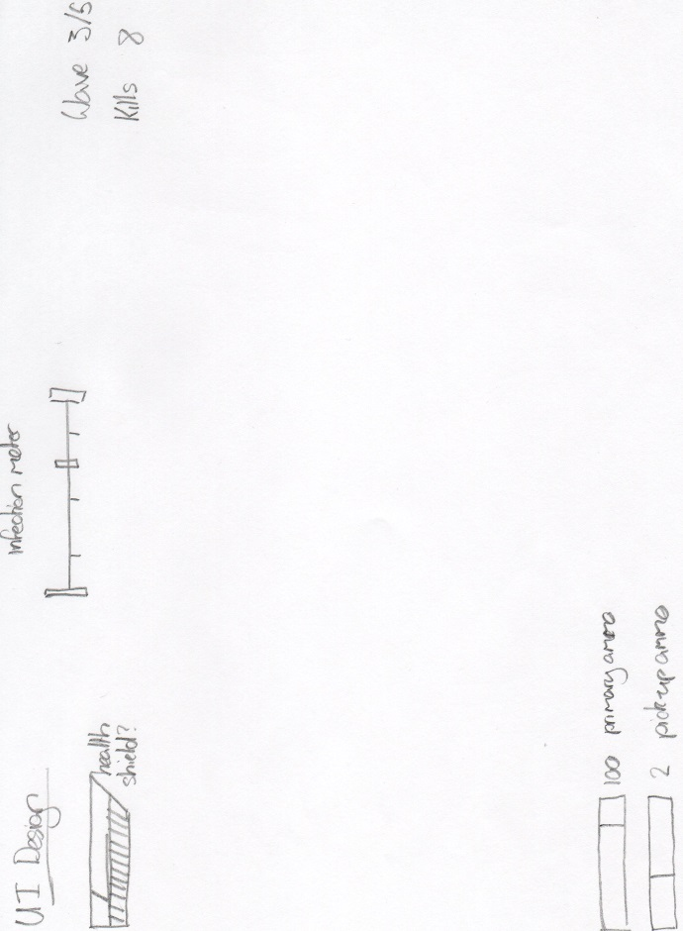

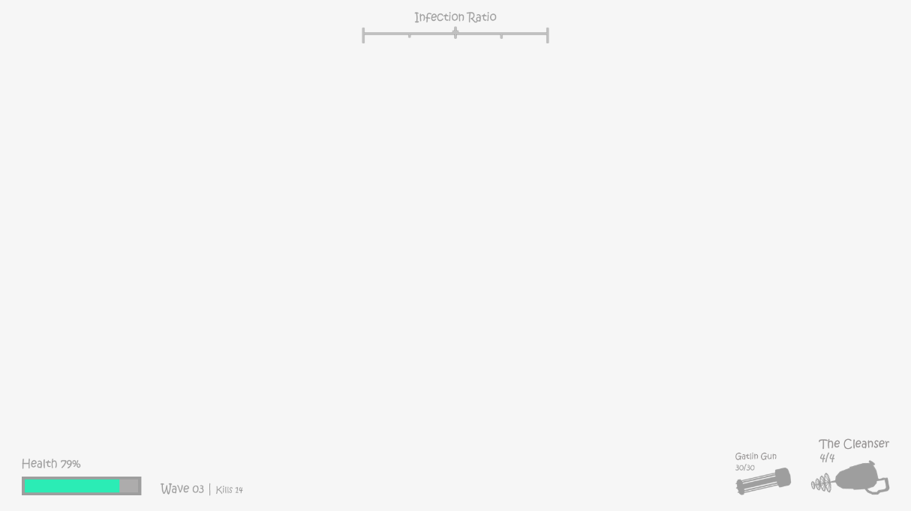

#### Level Design

The sketches for the layout of the level have been drawn from many different viewpoints in order to make it very clear how it will look when being created in a modelling environment.  
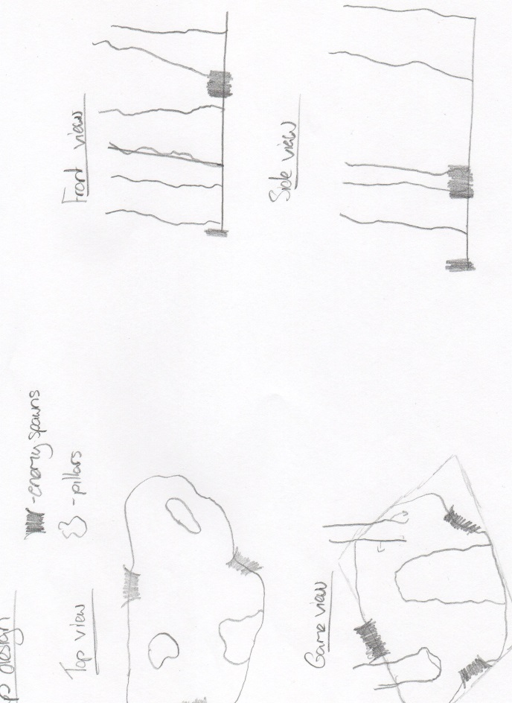

### Weapon Designs

There are three main weapons available to the player as can be seen below. The primary weapon; the main weapon and two pick-up weapons; the cleanser & the boomer.  
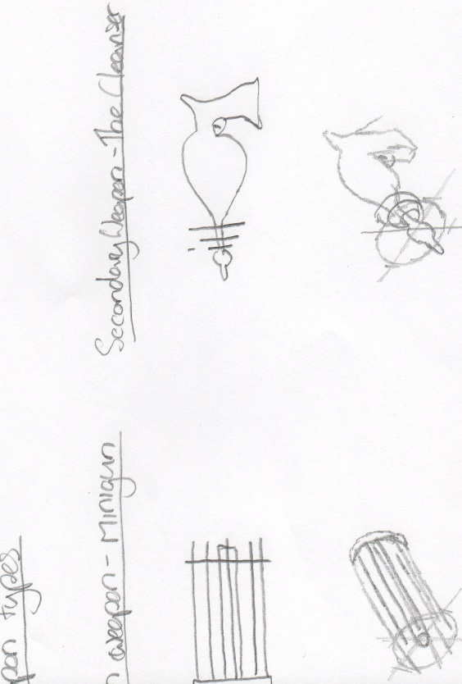  
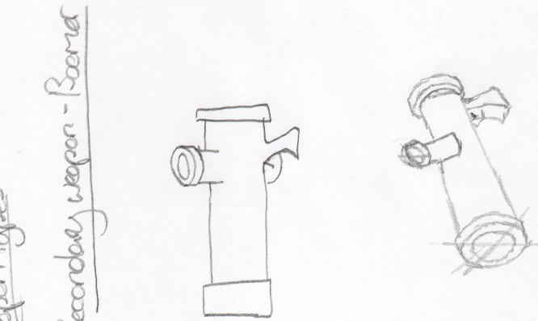

1. Image taken from www.life-enthusiast.com/files/BrandsImages/Allegany//Bacteria4.png
2. Image taken from s3.envato.com/files/60872917/1.jpg
3. Image taken from probioticamerica.com/perfect_flora/images/bas-bacteria.png